CS 255 System Design Document Template

UML Diagrams

UML Use Case Diagram
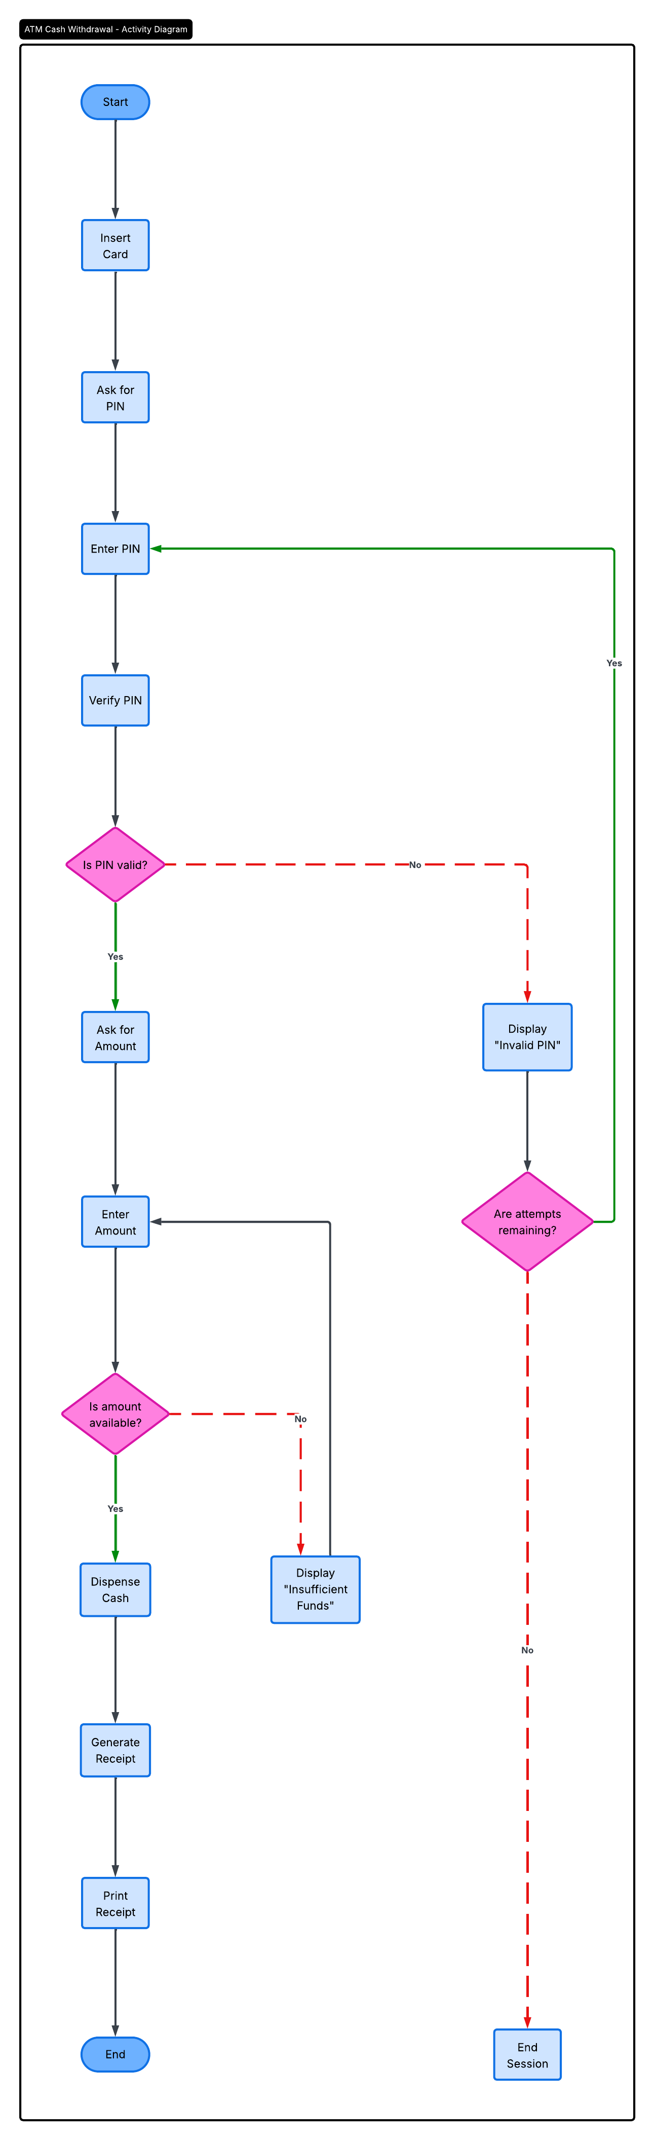

UML Activity Diagrams
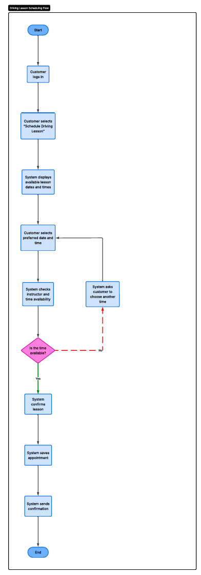
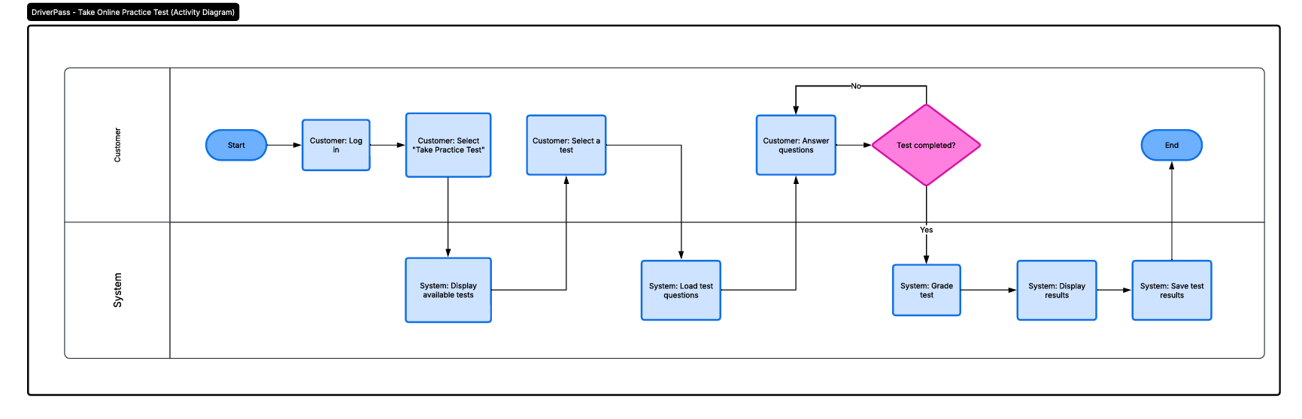

UML Sequence Diagram
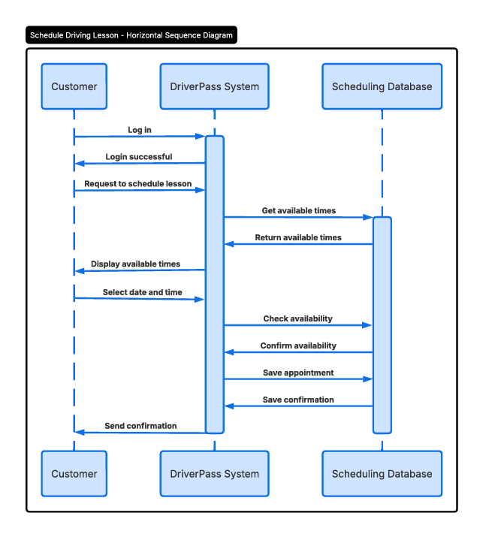

UML Class Diagram
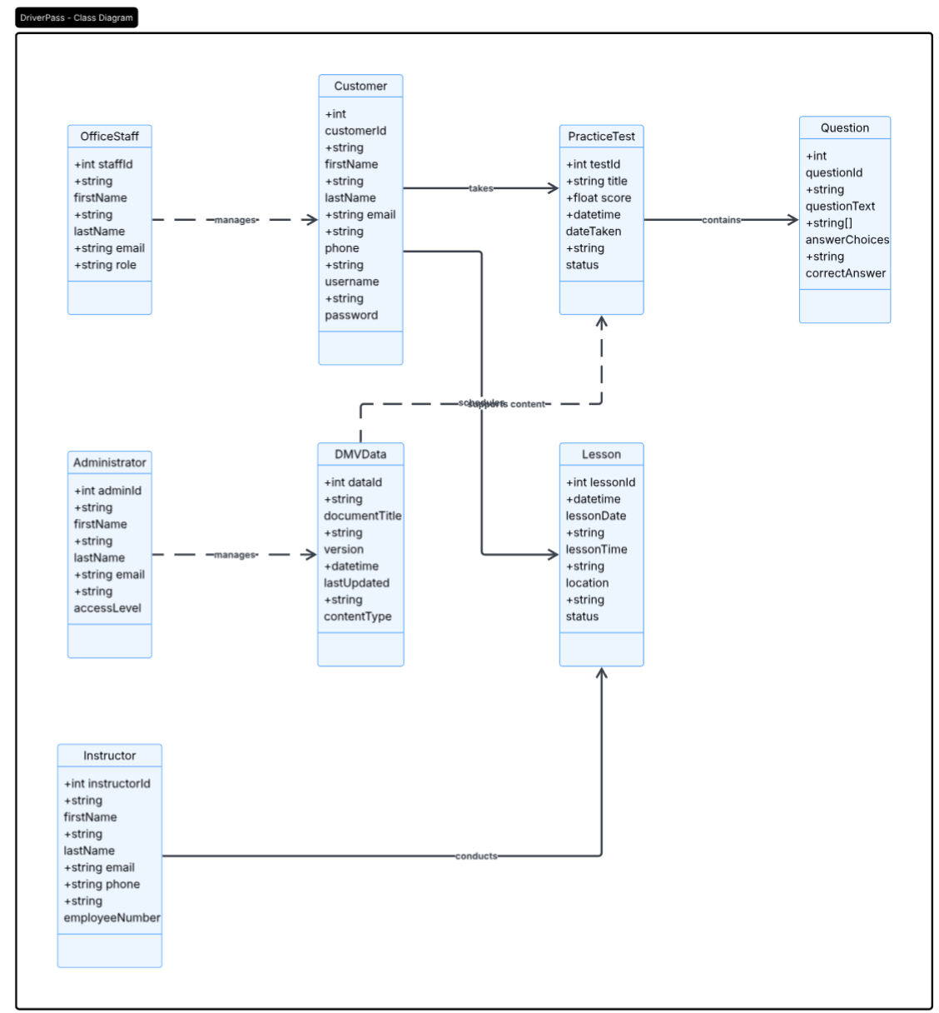

Technical Requirements

For the DriverPass system to function correctly, the appropriate hardware, software, and internet configuration are required. Customers and employees should be able to access the system on PCs, tablets, and smartphones because it is web-based. Customers can use this to log in, plan driving lessons, and take online practice exams, and staff can handle scheduling and customer data.
In terms of hardware, the system would require cloud storage or secure servers to protect test data, timetables, and client records. Instructors may check lesson schedules using tablets or mobile devices, but office workers would require computers to access and maintain the system.

In terms of software, the system would require a database to store data, a web application, and security technologies to safeguard user information. To ensure that each sort of user only sees the portions of the system they require, it should incorporate login protection and various access levels. For the DMV practice test data to remain up to date, the system must also be updated on a regular basis.
In addition, the system requires a dependable internet connection, safe storage, backup support, and sufficient capacity to accommodate several users concurrently. These technical specifications would enable DriverPass to offer a dependable, safe, and user-friendly system.

